Latest update: 5 December 2017

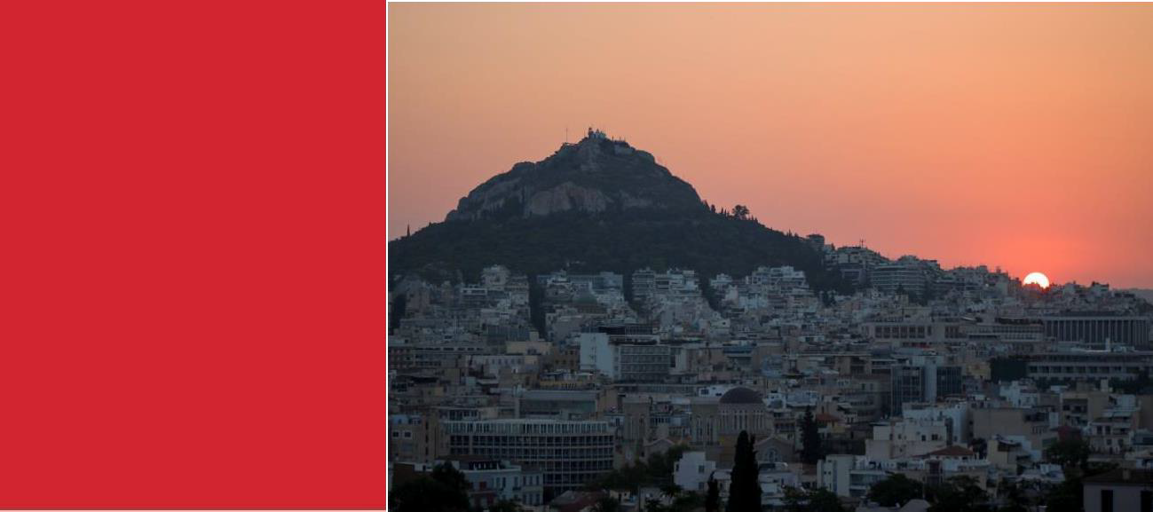
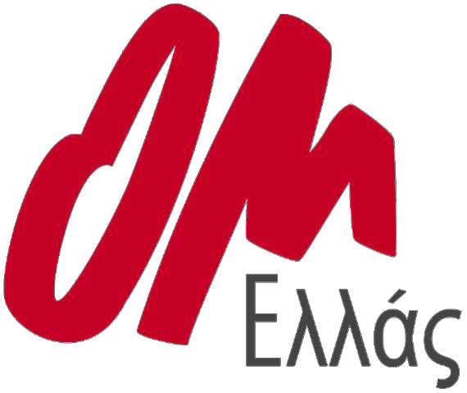

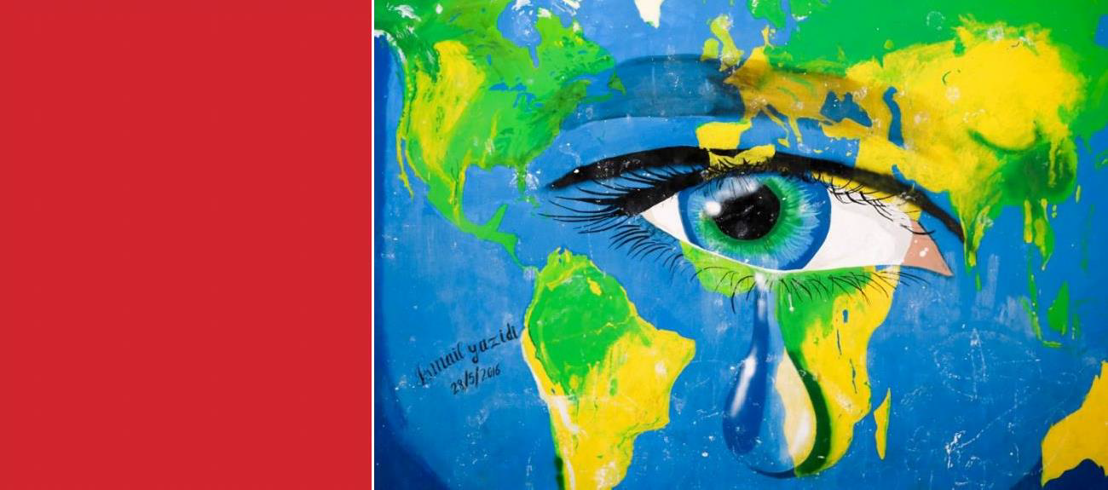

Welcome to Greece

Contents
Introduction 3
OM Hellas (Greece) 4
Ministries of OM Hellas 4
OM Hellas Emergency Contacts 6
Pre-arrival Medical Information 7
Traveling from the Airport into the city 8
Dress Code 10
Packing List 11
Your Role 12
Culture 12

Introduction

Welcome to OM Hellas. It is wonderful that you are coming serve with us and we are so thankful to have you. This manual has been designed to inform you of some basic information about the work of OM Hellas, living and working in Athens, a list of things we would advise you to bring and have sorted before you come, and some information regarding the ministries you will be involved with while you are with us. When you arrive, you will be given a more detailed orientation but please take time to read this before you arrive and we look forward to meeting and serving with you.

GOD CALLED YOU HERE
We believe that God is speaking to each of us and that He has called every volunteer and member of our team to serve here in Athens. He has a purpose for each of us in Greece for however long we stay.

Throughout your time here you will be given a schedule which will allow you to experience and serve in a range of areas. Most important however, is your relationship with God as you do this. As you serve we ask that you spend time with God and seek His guidance through prayer, not only so that you can be a blessing to those you are serving, but also so that you can grow as a Christian and discover why God has brought you to Greece.

The nature of our ministry means that things change continuously, often on a daily basis. On
occasion when thing don’t go to plan we ask that you spend your unexpected free time with God in focused prayer times, and in prayer for our city, the ministries you have been to or will be involved with and the people you have met. There is no such thing as too much prayer!

IT IS IMPORTANT TO REMEMBER…
We are not here with a solely humanitarian focus. Our hope is not based on manpower and resources. Rather, we rely on God, His power, His provision and His wisdom, because without God- given grace it is very hard to do this work and to do it with a heart of love without becoming emotionally and spiritually drained.
Athens is a difficult city to live and work in as a Christian because there is so much need and it is so apparent wherever you go, which can be very overwhelming. For many volunteers and long-term workers, often the question comes to mind, “Does what we do even make a difference?” But in these moments, we are reminded and firmly believe that God has called each of us specifically to this city because we have something that is needed here. God is working here, He was before we arrived and He will continue to work faithfully after we leave. So, take heart and rejoice that God is faithful, even when it seems impossible and we are struggling.

TAKE TIME…
Because of this we would advise to you take some time every day to process you experiences with other team members and quietly by yourself. This is important, even if you don’t feel overwhelmed, because often things can build up overtime and we don’t realize until it is a bigger issue than it

needs to be. Simply talking through the day and praying for each-other allows you to give the day to God and start the next day fresh. We ask that every team takes time for a debrief session at the end of every ministry activity.
We cannot emphasize enough that you should respect the local population. Invest in relationships, listen to stories and try to get an idea of how things are done around here. Clean up after yourself, serve people, be friendly and show Jesus’ love to everyone. The people of Greece have been facing hardship for many years and their community-life and economy are suffering. You'll see that many of the locals are compassionate, hospitable and willing to help you out as long as you do not present yourself with an attitude of knowing better and taking over. By working with the people and by forming good relationships, we will be efficient in our ministry. We are not here to solely serve or love one people group, we are here to reach out to the locals, the refugees and our fellow volunteers.

OM Hellas (Greece)

OM HELLAS MISSION STATEMENT
To support the local church to witness Christ locally and globally.

OM HELLAS VISION STATEMENT
United communities of believers reflecting Christ in the world.

Our understanding of the Vision Statement:
- Communities: Cross cultural, cross generational, cross denominational.
- Reflecting Christ: in word and in deed, being mission minded, serving, forgiving, being His hands and feet, being discipled and discipling.
- In the world: Both in Greece and overseas, to people who are not in a relationship with Christ, not just for full-time ‘Christian workers’ but for everyone.

OM Hellas seeks to respond to every situation by sharing the message of hope through Christ, while meeting the basic needs of the neediest. Local churches are realizing that they need to reach out but often lack the necessary resources. Therefore, OM Hellas is partnering with several different evangelical churches and other Christian organizations in Athens. We are involved in several different ministries, including Mercy Ministries and Justice Ministries and it is a misconception is that we only work with the refugees. The following page is an outline to give you an idea of the current work that is being done on a weekly basis.

Ministries of OM Hellas

MERCY MINISTRIES
- Working with local Evangelical Churches, helping with distribution of food and clothes to the homeless.
- Supporting a local Evangelical Church at their drop-in center where people in need can come for bible study, to shower, wash their clothes, to receive fellowship and have a cup of coffee or tea.

JUSTICE MINISTRIES
  - Nea Zoi (New Life) - A local ministry that works with men and women in brothels and on the streets. Visit neazoi.org for more information.
  - Threads of Hope - Women who have left prostitution are employed by this business following the successful completion of the training at Nea Zoi. Visit www.threadsofhope.gr for more information.
  - Damaris House - Supporting the women by doing practical work such as gardening, putting together furniture and cleaning at the house for women. For more information visit www.damaris.gr

REFUGEE MINISTRY
-Visiting a range of refugee camps and building relationship with the refugees and developing programs for children, women and giving English/German lessons.
  - Working with and supporting local Churches and other Christian organizations which are also address the refugee crisis. (Watch https://vimeo.com/195032704 to see an example of a church we work with each week.)

MUSLIM MINISTRY
  - Discipling, mentoring and equipping new believers and partnering with local churches that are ministering to Muslim background believers.

LITERATURE
  - Providing quality Christian literature to the communities and individuals that require it. This includes Bibles in various languages.

UI (UNITED TO IMPACT)
  - Working with youth from both local and migrant churches and gathering together to impact their communities through prayer, music, arts and sports.

CHURCH RELATIONS
  - Building relationships with local and migrant churches and partnering and supporting with them in their ministries.
At the beginning of 2015 the OM Hellas team grew considerably and has and is continuing to grow. The current team members are:

Name | Nationality | Role
Gabby Markus  Evie Markus | Papua New Guinea  Greece | Field Leader, Leadership Team, Church Mobilizing Team  TeenStreet Coordinator, Church Mobilization
Greg Low Suanne Li | Singapore Hong Kong | Leadership Team, IT Officer, United to Impact Coordinator  Church Mobilizing Coordinator, United to Impact Coordinator
Damaris Helwig | South Africa | Leadership Team, Administration Officer
Vasilis Kapetanidis | Greece | Refugee Ministry Team Manager
Devin Jones | USA | Short Term Coordinator

Lornie Caplan | United Kingdom | Hospitality Coordinator, Literature Ministry
Manny Cardenas | Philippines/Greece | Refugee Project Team
Fion Lau | Hong Kong | Refugee Project Team
Hester Roos | The Netherlands | Communication Officer, Refugee Site Coordinator
Martin van Asperen Anton van Asperen | The Netherlands The Netherlands | Muslim Ministry, Cultural Facilitator Muslim Ministry, Cultural Facilitator
Ellen Cardenas | Philippines/Greece | Assoc. Field Personnel Officer, Muslim Ministry Team
Spiros Vampoulas  Marja Vampoulas | Finland/Greece  Finland | Finance Officer, Northern Greece Ministry Leader  Graphic Designer
Filimon Diamantatos | Greece | Finance Officer
Rosie Hooton | United Kingdom | Field Personnel Officer, Justice Ministry Leader

We also have 10 children (ranging from 0-16ys) along for the journey with their parents!

OM Hellas Emergency Contacts

OM Hellas Office
Office Address: | Mailing Address: | Phone Number:
Veikou 60G 117 41 Koukaki Athens, Greece (3rd Floor) | PO Box 19110  117 01 Koukaki Athens, Greece | +30 210 921 6371  Nearest Metro Station: Syngrou Fix

OM Hellas Personnel | Position | Phone Number
Devin Jones | Short Term Missions Coordinator | +30 694 98 40 643
Vasilis Kapetanidis | Refugee Ministry Team Manager | +30 698 119 1420
Lornie Caplan | Hospitality Coordinator | +30 6988 6666 93

Emergency Contacts in Athens
Local Police | 100
Emergency line (USA 911 Equivalent) | 112
Closest Police Station to Office | Veikou 43, Koukaki, 11742 Athens
Nearest Hospital to Office | Evangelismos Hospital, Ipsilantou 45  (However only a few hospitals are open for ER in the nights, on a rotation. Call 112 to check which, in case of emergency)

Pre-arrival Medical Information

OM Hellas’ ministries are all people based which includes work among homeless people, children and adults and in refugee camps, so conditions vary. Therefore, we would advise you to prepare yourself physically for your time here, specifically in regards to vaccinations, which are strongly advised.

The additional suggested medical information is meant to be used as a checklist for ensuring optimal physical stamina, health and well-being during your time in Greece.

Following these recommendations will fall under the volunteers’ own responsibility.
Vaccinations Recommended:
Certificate of vaccination for the following: Hepatitis types A + B
Mumps, measles, rubella (MMR) Tetanus, diphtheria, polio, pertussis Tuberculosis

Additional Suggested Information:
Medical card (if you have, with: blood type, allergies...)
Insurance card (to show your insurance covers the trip; keep this in your wallet, in case of an accident)

Additional Suggested Medications: Personal medication
Pain medication (treating pain, fever, inflammation…)
Travel medication (treating nausea, vomiting, diarrhea…)
Additional medication (treating insect bite reactions, allergic reactions...)

Additional Suggested Items:
A basic first aid kit- including thermometer, tweezers, scissors, antiseptic ointment, plasters/ band-aids, sunscreen, mosquito spray, hand sanitizer.

***If you have a medical condition, it is imperative that let your OM leader know and bring the proper medication.
Be sure your OM leader knows where to find the medication in case of an emergency.***
For example, if you have asthma, bring your inhaler, and any other medication, and let your leader know where to find it in case of an asthma attack. Watch https://vimeo.com/195032704
***If you are currently taking medication, please know the exact name and dosage of your

Traveling from the Airport into the city

If you are traveling as a team and have been told you will be picked up from the airport, we will be there! If you come as an individual, due to the fact we are understaffed as a team, we ask that you make your own way to Athens using these instructions. We will get in contact with you in case we have the capacity to pick you up.

TRAVELING WITH THE METRO
    - The metro stops running in the night. The last one leaves the airport at 23:30.
    - Check the departure times here: http://www.athensairporttaxi.com/metro/timetable-from- airport
    - Costs: 10,00 €
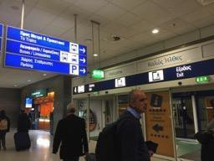1. From the arrivals, make your way out of the airport building to the Metro/Train station and follow the signs.

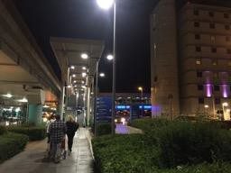
- You must leave the building and cross the road, then ascend the escalator to the overhead pedestrian bridge. Follow the bridge to the metro station.
- On the side of the station are machines (with English language option). There you should
purchase a €10.00 one-way ticket from the airport.
3

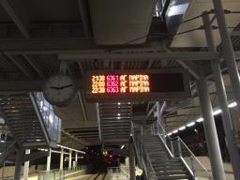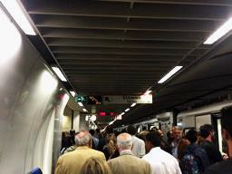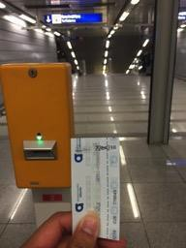
6
8
6. The Metro from the airport leaves about every 30 mins in the direction of AGHIA MARINA.
7. Once you get on the Metro you are now on the BLUE line. Stay on this line until SYNTAGMA Station (it takes 38 minutes).
8. At SYNTAGMA Station you should ascend the escalators to the RED line towards ELLINIKO. Change trains and stay on the red line for TWO stops until SYGROU FIX Station.
9. Once at SYGROU FIX you should alight and ascend to the street level via the lefthand Leof. Syngrou / Drakou exit and meet your OM Hellas contact near Goody’s Burger shop.
4. Before you descend to the platform level there are posts where you can stamp/validate your ticket.
DO NOT FORGET TO VALIDATE YOUR TICKET!
4
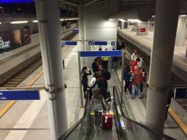
5. Descend to the platform level and make sure you are on the side that says METRO, NOT SUBURBAN RAILWAY. It should be the inside track.
5

TRAVELING WITH THE BUS
- Leave the airport building. The bus station is located between Exit 4 and 5 at the arrivals level. The bus X95 leaves every 15 minutes. Here is the time table: http://www.athensairportbus.com/en/timetable/x95airporttoathensdowntown.html

- Get your ticket: Tickets are available from the bus drivers, from the ticket kiosk at the bus departure area and from all the metro stations around Athens.

Ticket price: There are only one-way tickets and cost 6.00 €. Children under 6 years can travel
free. Half-price tickets at 3,00 € are available for:
  - Students upon showing their Student Card (University ID) plus Passport or ID
  - People of age 6 to 18 years old
  - People older than 65 years when showing their ID

- Enter the bus and travel till the last stop – SYNTAGMA (it takes ca. 40-50 minutes)

- From there you can either take the metro or a taxi. The STM coordinator will let you know where to meet.

TRAVELING WITH A TAXI
- You can pick any taxi or we can ask one of our team member’s brother (who is a taxi driver) to pick you up. His name is Panagiotis and that is his number: +30 697 818-4077. Let us know if we should contact him for you.
- Cost: ca. 55 € night time (00.01am to 05.00am), ca. 38 € (daytime). These are fixed prices from
the center of Athens to the airport or vice versa.

Dress Code

OM has a dress code which we would ask that you take into consideration when you are packing. Whatever our personal opinions are about style, we want to respect the people we are partnering with and ministering to and we do not want our appearance to be a stumbling block to them.

Volunteers should not wear revealing clothing at any time. Short shorts are not acceptable and shoulders should be covered. Clothing should not be skin tight. Any obscene or inappropriate images or phrases on t-shirts may not be worn. When working at ministries or when with locals, e.g. at Church, the dress code must be respected. Men are not allowed to wear jewelry.

While working specifically with refugees:

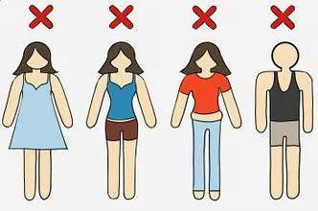
Men
Shoulders covered (no tank tops) Pants preferred over shorts
For Summer time: Accessories to keep the sun off (ball caps and sunglasses)

WOMEN
Shoulders, collar bone and elbows covered (no tank tops!)
Loose clothes
Long skirts or loose pants (no tight fighting clothing and no shorts)
Longs shirts to cover the butt
Cover lap with scarf while sitting if wearing pants
No dangling earrings or hair down (both are signs of “availability”)
For summer time: Accessories to keep the sun off (ball caps and sunglasses)

Packing List

SUPPLIES FOR YOURSELF
- Bible
- Note Book/ Journal
- Money pouches for around the neck to keep money safe whilst in Athens
- Water Bottle
- Phone with translation apps
- Toiletries (tooth-brush, shampoo etc.)
- Hand Sanitizer/ wet wipes
- Skirts for the women (for refugee camps but also church visits)
- Long shirts that will cover the butt
- Adapter if needed
- Instruments (to play with the refugees, you are responsible for your own equipment)
- For summer time:
  - Hat / sunglasses
  - Sunscreen
  - Mosquito repellent
  - Swimming costume >> Nothing too revealing, many people swim with shorts/tank top

SUPPLIES FOR MINISTRIES AND REFUGEES
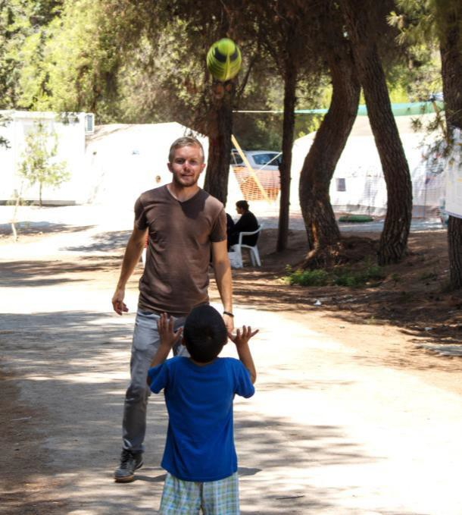
If you would like to bring something for the refugees, please check first with OM Hellas that this would be appropriate. Also, if it is possible to buy the items in Greece, e.g. school supplies, we would encourage you to bring money so you can purchase these things in Athens and therefore be supporting of the local economy.

If you would like to bring some small gifts to give away, we would suggest,
Money Pouches for around the neck which will allow refugees to carry their money and passport around safely
Jumping ropes, footballs, soccer balls for the children.

Your Role

As a volunteer with OM Hellas you are coming to serve with us in our ministries. Our goal is to build relationships with the people we meet with the hope of sharing the Good News of the Gospel and the love of Jesus Christ. This service can take many different forms. It may be cleaning, sorting clothes, preparing food, taking someone out for coffee, teaching English, visiting families in their homes, playing with the children, doing craft. The possibilities are endless!

As a short-term volunteer, it is important to view yourself as part of a much larger picture that God is unfolding in Greece. The genuine love and care shown to both the locals and the refugees by previous volunteers has opened the door to for us to build meaningful and trusting relationships. This has led to Gospel presentations to people who may never have had the chance to hear it otherwise. You may be able to share the Gospel because of the part played by previous volunteers. So be encouraged, if you are asked to spend time sorting clothes or playing with the children, you are part of a massive picture in which people are being introduced to Christ and accepting Him in their lives and your role is invaluable.

It is important that you DO NOT feel pressured to share the Gospel every time you have a conversation! Often ears that are truly listening and hearts of love makes a much larger impact than constant preaching. The genuine love and care you show the people in Greece during your time may open even greater doors for short-term and long-term volunteers.

CULTURE

THE MIDDLE EAST
The larger region of the "Middle East" stretches from the Atlantic Ocean in the West to Afghanistan in the East. This includes the countries of Morocco, Algeria, Tunisia, Libya, Egypt, Israel, Lebanon, Syria, Jordan, Saudi Arabia, Kuwait, Mauritania, Sudan, Bahrain, Qatar, the United Arab Emirates, Oman, Yemen, Iraq, Turkey, Afghanistan and Iran.

Although these countries are close geographically speaking, they can be extremely diverse in practices and culture. There are many smaller divisions and sub-cultures/sub-ethnicities from these countries with a complex history. The best way to approach this is to not make assumptions from your limited knowledge and instead be open to learning about the different people groups and know how to act in a way that opens up missional opportunities within the cultures.

Religion is considered the largest influence on both the visible and invisible aspects of these nation's cultures. Examples of the visible being the clothing worn, gender roles, and food eaten. Invisible being the spiritual beliefs and moral law that give purpose and meaning to lifestyle. Islam is the religion of an overwhelming majority of the population. The Prophet Mohammed recognized the Jews and Christians as "People of the Book," recipients of a true but incomplete revelation.

Men are the head of religion, government, and the home. Women are often kept separate in social situations and gender roles are quite defined. Because of the general poor treatment of women, the genders have learnt to not interact with each other outside of marriages. Men talk to men. Women talk to women. This aspect of culture can make Westerners uncomfortable and seems to have real limitations for missional conversations and teaching. Regardless of your views, we must remember that everything is redeemable by God and He will make a way for revelation of Himself despite rigid communication boundaries. Don't be discouraged!

A major aspect of Middle Eastern culture is the warm hospitality of its people. When you interact with these people groups you will see a trend of generosity. This is a great way to build meaningful relationships. Keep in mind that that visiting them and accepting their gifts shows them respect so do not feel like you are imposing or that you should decline to be polite.

It is important to be culturally sensitive when working with people from a Muslim background and culture in order to open opportunities for us to build relationships and minister. Here are some things to take note of in order to respect their culture and not create barriers for sharing your faith.

Avoid physical touch between yourself and someone of the opposite gender. It may lead to offence/misunderstanding.
Be aware of how you interact with other volunteers. Hugs and other physical touch may not be understood by the people we are serving.
Men may not be used to open and direct conversation with women in the way that we are familiar with it in the West. Your friendliness may be mistaken for something else.
Avoid too much eye-contact or smiling at persons of the opposite gender. Take note of the dress codes described in the dress code section above.
When eating with your hands, only use your right hand. The left hand is considered “dirty”.
Many cultures are not as direct as in the West so do not be offended if questions are not answered in a straightforward manner. It is common that people do not outright say “no” but rather sidestep a question. Additionally, if you are asked a question you prefer not to answer, do not feel pressured to respond directly. Example, the question “How old are you?”, “I am old enough to be here”/ “I am an adult” are appropriate answers.
If at any time you become uncomfortable in a situation, it is alright to excuse yourself and find a leader. Do not feel pressured into doing something if you are not comfortable.

Who Speaks what?

It would be helpful to have a translator on your phone, such as Google Translate. Here you can download dictionaries so they are available off-line.

- Arabic
  - Syrians
  - Kurds
  - Iraqi
  - Egyptians (Egypt is the “Hollywood” of the Arabic entertainment world so most
people understand this dialect/accent)

- Persian
  - Iranians (Farsi – Modern)
  - Afghans (Dari – Traditional)

GREECE

One of the first things that you should note about Greece and the Greeks is that they are not strictly Western, neither are they completely European in their cultural orientation. Here in Greece we find a mixture of east and west. Greeks are warm, friendly and hospitable people. Their culture obliges them to be hospitable and helpful to foreigners and guests.

The Greeks are very proud of their history, and rightly so. Democracy was created in Greece and the Greeks are very much aware of it. All this is for them a great heritage that they carry with them all of their lives. However, modern Greece has been characterized by political instability and today after the financial crisis Greeks have much uncertainty about the future.

When a westerner comes to Greece he is likely to be perceived as a guest. However, to build a relationship with the Greeks requires much intimacy, concern by the westerner for the Greek's welfare and self- sacrifice. The westerner is often unprepared for this type of relationship. He cannot accept the degree of intimacy or the self-sacrifice required by the Greeks, because he prefers his western privacy. So, he takes a little bit of distance to save himself. This behavior is then seen by the Greeks as indifference.

The family is incredibly important in Greek culture, and children are the most important. The central role in the western family is husband - wife. The central role in the Greek family is parent - child. This means parents tend to be very helpful to their children, taking every opportunity to assist and protect them, and make most of the decisions for both boys and girls.

Greece, is a ‘Christian’ nation, however it is Orthodox Christianity rather than Protestantism or Catholicism. The Orthodox Church have kept on many traditions and ways of doing things from the Old Testament and the Jewish tradition. One of the biggest stumbling blocks for us as Westerners is that many orthodox people do not own or read the Bible. There is no room for personal interpretation, rather they follow the priest’s teachings and interpretation. Greeks will say, 'Don't read the Word of God on your own, you will come to the wrong interpretation.” To have a personal relationship with God is also less common, similar to Catholicism, they believe that saints will intercede with God on their behalf and it is important to give them tokens of gratitude once a healing or something requested has occurred.

